Scenario is I have docker image I want to push to amazon ECR package management service.

1) follow the steps to push the docker image

2) create IAM role for we want to push from ec2 server to ECR registry (Amazon ec2container registry full access) so create one IAM role,which is used to communicate both services

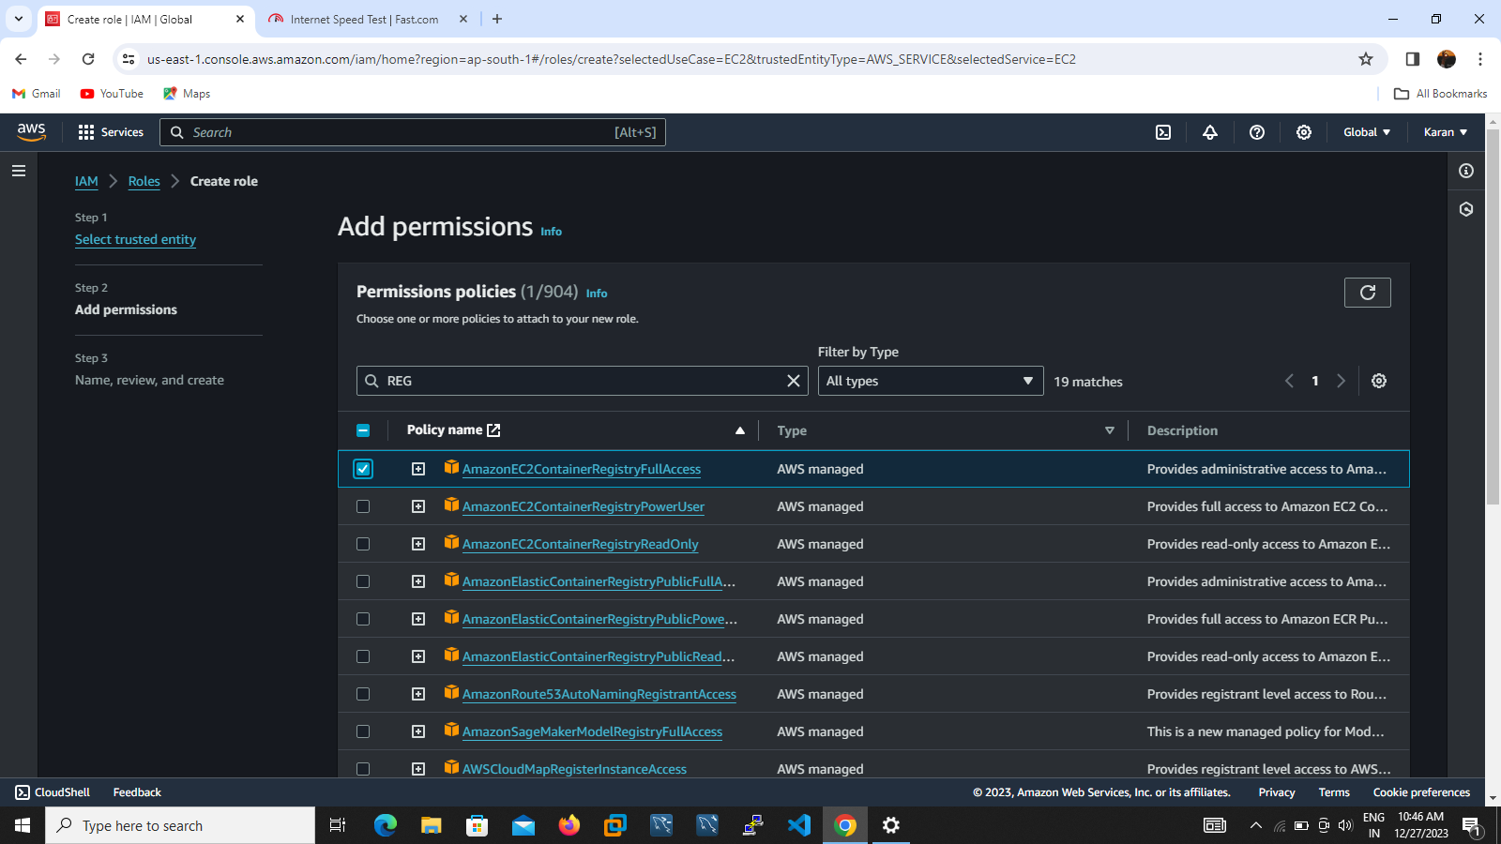

3) then the IAM role attached to EC2 instance server for commutation purpose

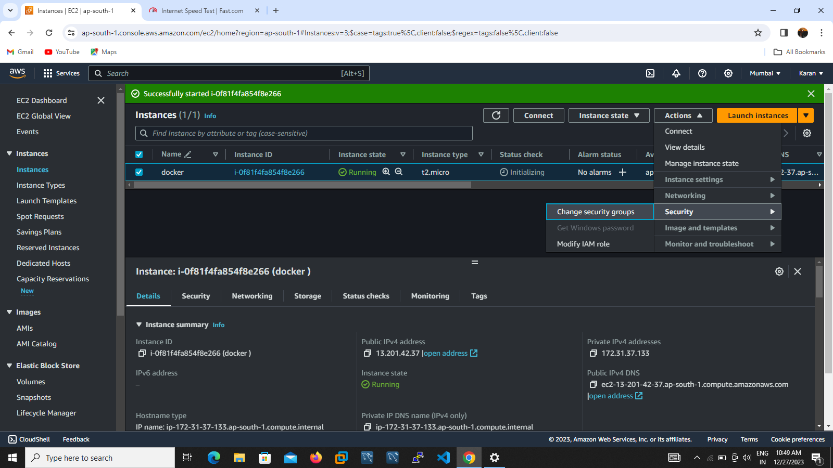

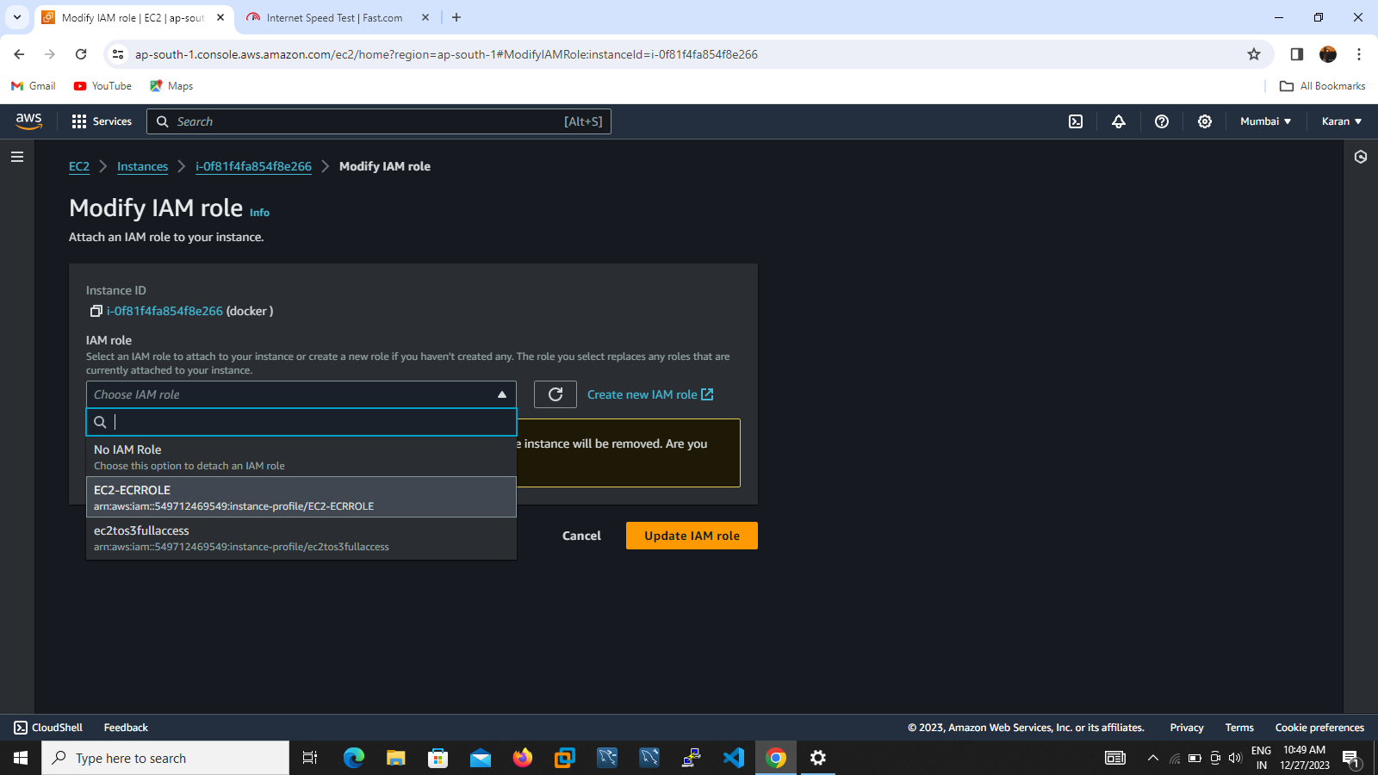

4) nxt step create one repository in amazon ECR provide name and create repository my repository name called as dockerrepositary

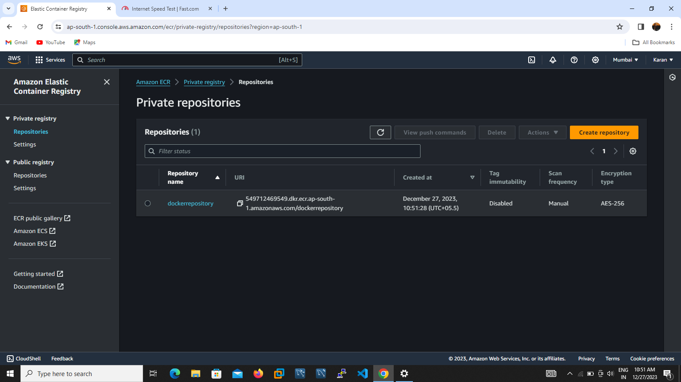

4) login to putty execute sudo su to take root user privileges

5) apt-get install to update our environment

6)apt-get install docker.io –y install the docker

7)pull any one web server I pull apache server (docker pull httpd)

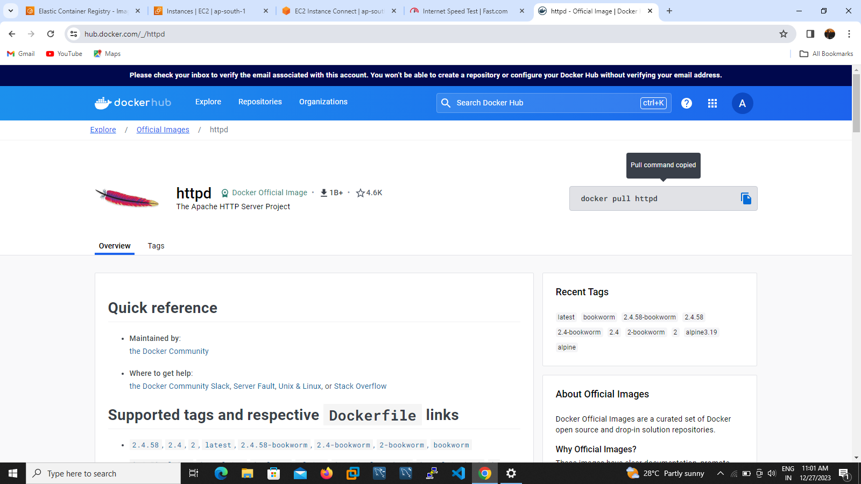

9)then go to inside of the repository in Amazone ECR execute the push command to view push command in console topside

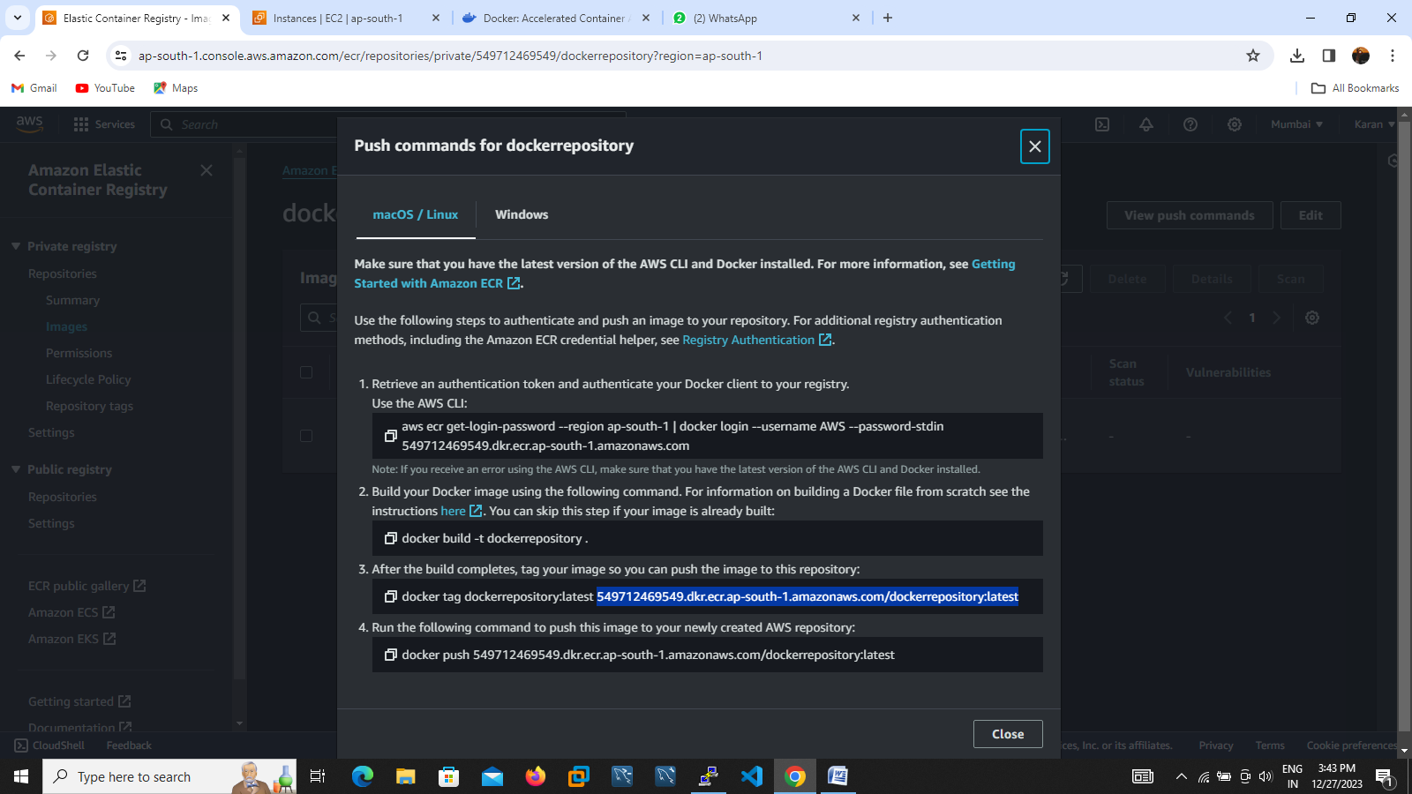

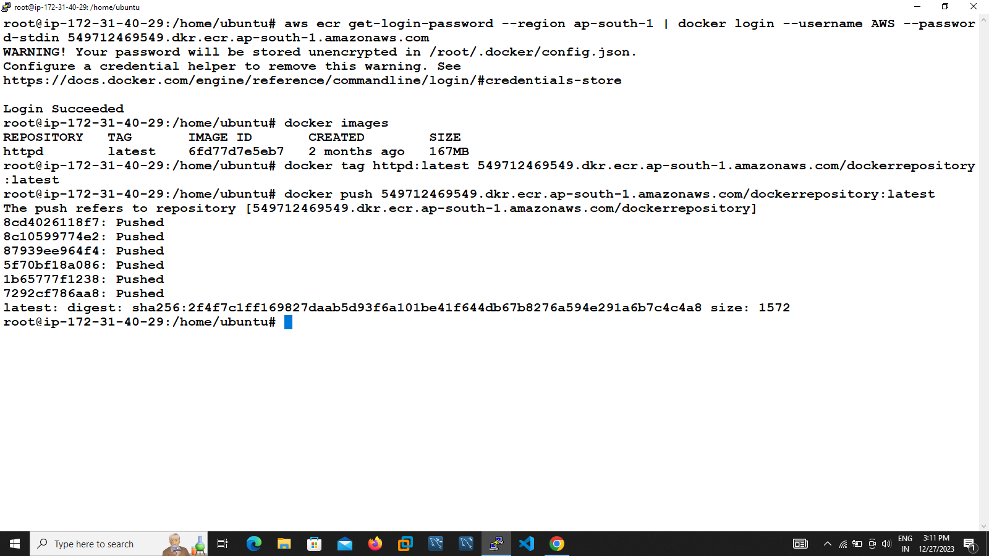

9)then execute the push command to view push command in console topside

10) aws ecr get-login-password --region ap-south-1 | docker login --username AWS --password-stdin 549712469549.dkr.ecr.ap-south-1.amazonaws.com

12)go yo the nxt step change the repository name httpd into docker repository path

13)execute the command $docker tag httpd:latest (here paste the amazon repository named path. (copy take from anmazome ecr respository)

14)execute the nxt command to nxt command to push successfully

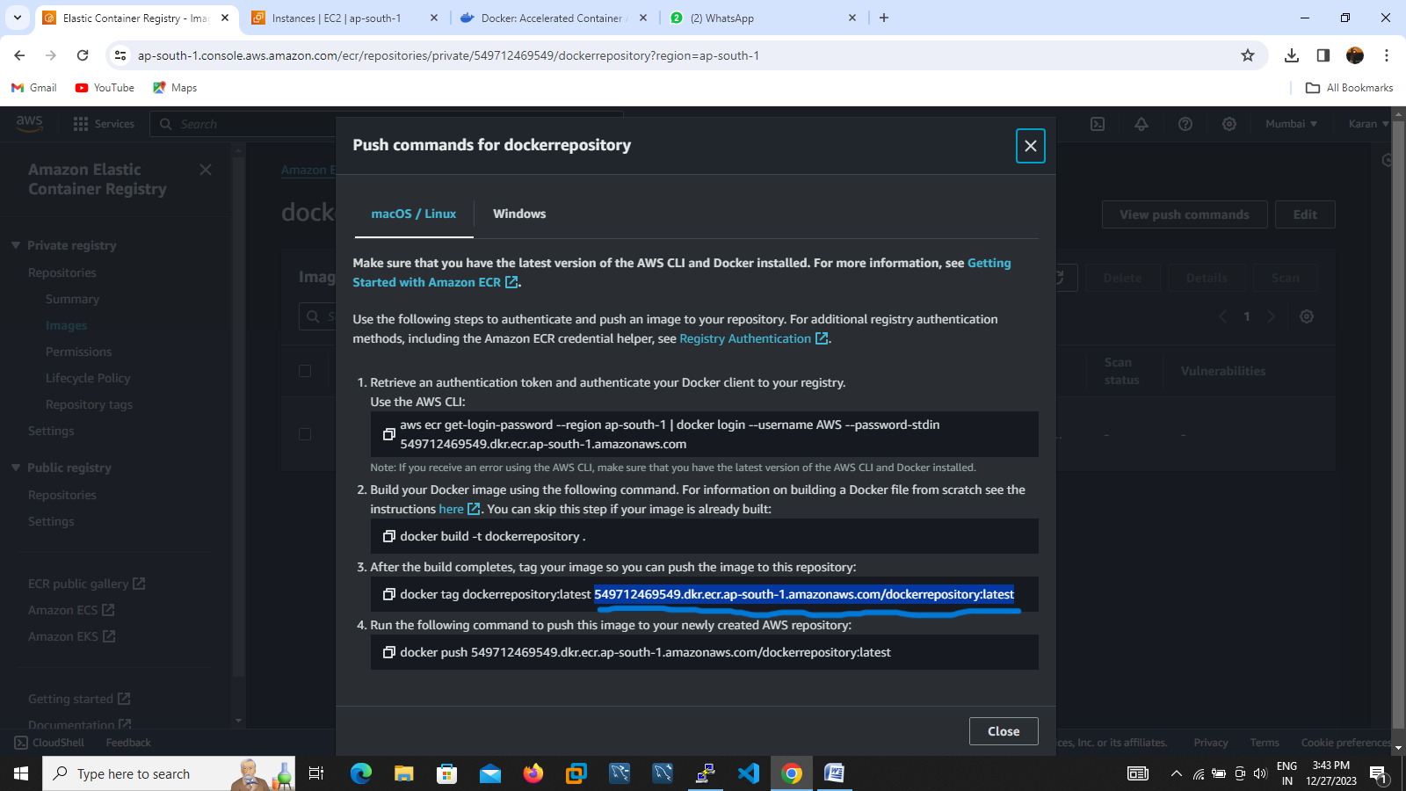



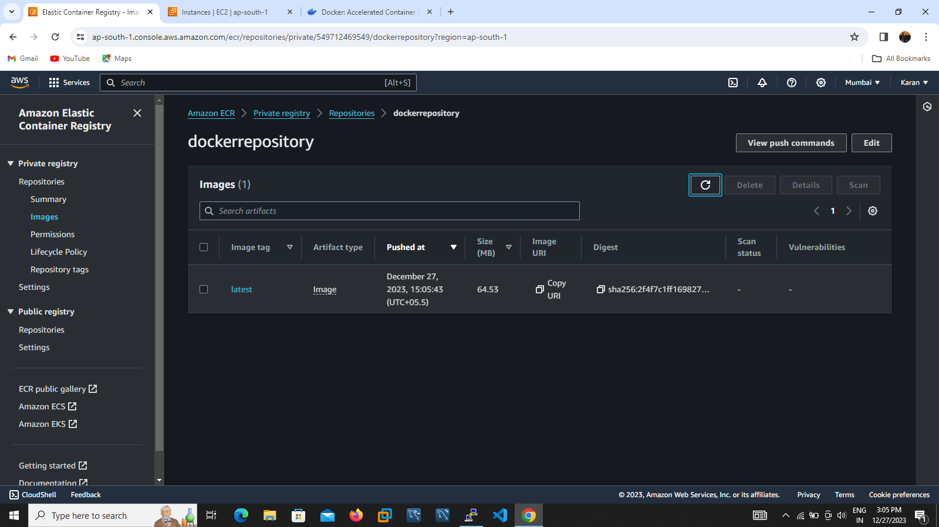

Image successfully pushed to repository